Section A (20 Marks)

- With aid of a well labelled digram, describe an experiment that could be done to determine molarity of sodium hydroxide (NaOH) solution using hydrochloric acid (HCl) of a known concentration.
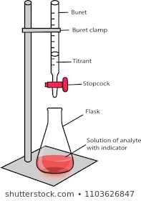
- 1 mark for the correct diagram
- 1 mark for any two correct labelling
- Place a known volume of NaOH into a conical flask^{1mark}
- Add few drops of Phenolphthalein indicator into conical flask containing NaoH and observe colour change^{1mark}.
- Fill the burette with HCl up to the zero mark and record as initial burette reading^{1mark}
- Drip HCl into conical flask while swirling the conical flask^{1mark}
- Stop dripping just after observing new colour change (turns colourless)^{1mark}
- Record the new level of the acid in the burette as final burette reading^{1mark}.
- Calculate volume of HCl used (Final burette reading – Initial burette reading)^{1mark}
- Calculate concentrate of HCL using the Formula :
$\frac{Vol of acid × Molarity oひ acid}{Number of moles of acid}$ = $\frac{Vol of base× Molarity oひ se}{Number of moles of base}$

- Draw a well labelled diagram, describe how spontaneous electrochemical cell can be developed from metals of Zinc and Aluminium (e.m.f: Al^{3+/}Al is -1.66V and Zn^{2+/}Zn is -0.76V).

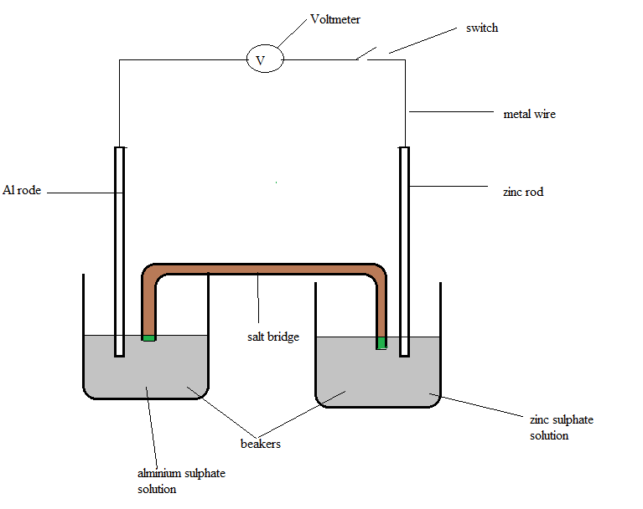
4marks
  - The process will need the following; two beakers, salt bridge ( potassium nitrate),
voltmeter, connecting wires, zinc and aluminium rod. 1mark
  - Calculate the electromotive force in order to determine which metal should be at
anode and which should be at cathode.
  - $E cell = ERHS- ELHS = - 0.76V - (- 1.66V)= 0.9V Reaction will be spontaneous$
  - $E cell = ERHS- ELHS = -1.66V - (- 0.76V) = -0.9V Reaction will be non-spontaneous 2marks$
  - Therefore, Zn is to the right hand side while aluminium is to the left hand side
  - Set up the materials as shown above 1 mark
  - Reaction at the left hand side will be oxidation (loosing electrons)while at the
  - right hand side will be reduction (gaining of electrons) 1mark
  - Salt bridge complete the setup and balances the ions in the two half cells 1mark
        - Al_{s} / Al³⁺ _{aq} // Zn²⁺_{aq} / Zn_{s} 1mark

Section B (20 Marks)
- You are provide with 3 test tube, measuring cylinder, distilled water, a test tube rack, copper sulphate solution, magnesium sulphate solution, iron sulphate solution, metal L, M and N.
  - Pour 5cm³ of copper sulphate solution in each of the 3 test tube
  - Place a shined piece of metal L, M and N in each test tube
  - Observe and record the results by indicating reaction or no reaction in the appropriate spaces in the table below
  - Rinse the test tube using distilled water
  - Repeate steps a to d using magnesium sulphate and iron suphate solution
Metal | Copper suphate solution | Magnesium suphate solution | Iron sulphate solution
L (copper) |  | No reaction | No reaction
M (magnesium) | Reaction |  | reaction
N (iron) | Reaction | No reaction

- Arrange the metals in order of reactivity,
M N L increasing reactivity (2 marks order plus arrow)

- Which metals is the strongest reducing agent?
M 1 mark

- Give a reason for your answer
Because can reduce all the metals 1 marks

- You are provided with materials; A, B and C which are metal oxides,three test tubes litmus paper, distilled water, test tubes and litmus papers (three red and three blue)
  - Set three test tubes in a rack.
  - Add 5 cm3 of water to the three test tubes.
  - Add half spatula of oxides A, B and C to each separate test tube respectively.
  - Shake each test tube
  - Dip red litmus paper in each of the test tubes, observe and record the colour change.
  - Dip blue litmus paper in each of the test tubes and observe the colour change.
Oxides | Colour change
 | Blue litmus paper | Red litmus paper
A | Blue(no color change) | Change to blue
B | Blue no colour change | Change to blue
C | Colour changes to red | No colour change (red)
(6 marks)
  - Identify acidic and basic oxides’
i.acidic: C (aluminum oxide)
ii. basic: A (sodium oxide) and B (calcium oxide)
  - Give a reason for your answer in 4g.
Basic oxide changes red litmus paper to blue when dissolved in water (1)
Acidic oxide changes blue litmus paper to red when dissolved in water (1)

(2 marks)

End of Question Paper

